

Registration/Sign-In Kiosk Partner Guide

Table of Contents

Website Access 3

Partner Sign In 4

Partner Homepage 5

Transaction Reporting 6

Visitor Reporting 7

## Website Access

To access the PA CareerLink Registration system website, open your web browser and type [www.scwdbpacl.com](http://www.scwdbpacl.com). On the main sign in page, click the Partners button located on the top left side of the page under the CareerLink logo. The figure below shows the systems main login page where the partner will select “Partners”.

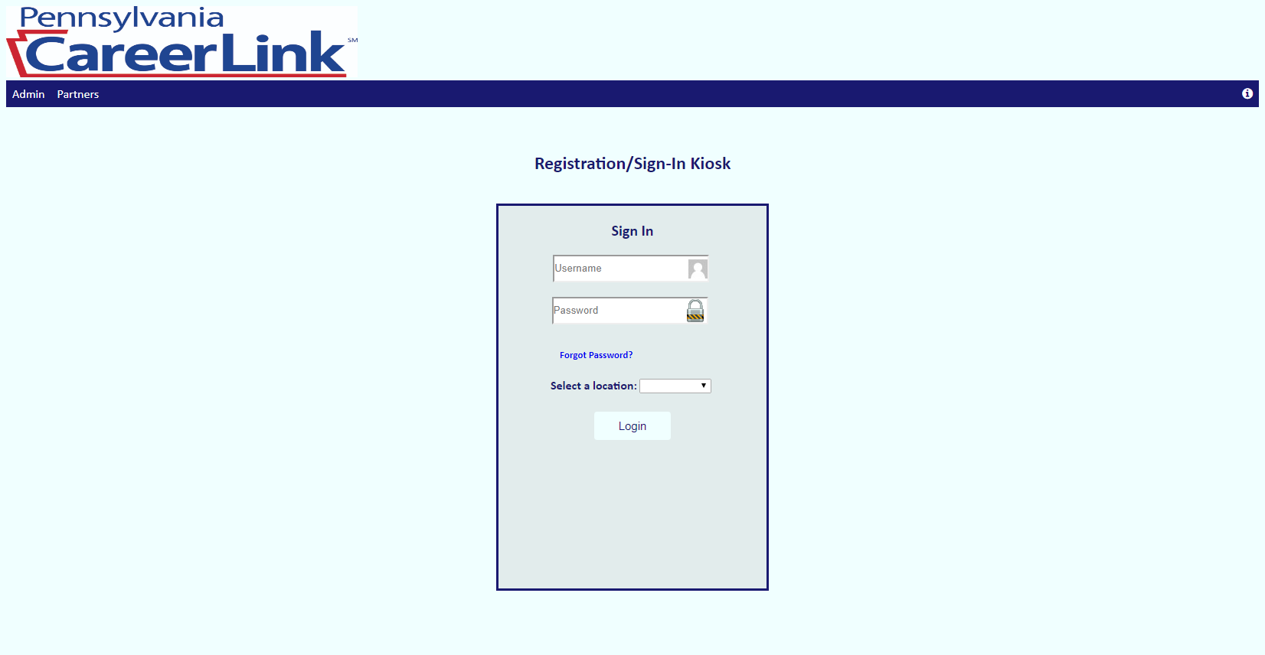

Once Partners is selected, the partner will be redirected to the Partner Sign in page.

## Partner Sign In

Once the partner has been redirected to the partner sign in page, they will enter their credentials into the username and password boxes. (Credentials will be given to the partner). The partner will then click the Login button. If their credentials are in the system, they will be redirected to the Partner homepage. The figure below shows the Partner Sign-In page.

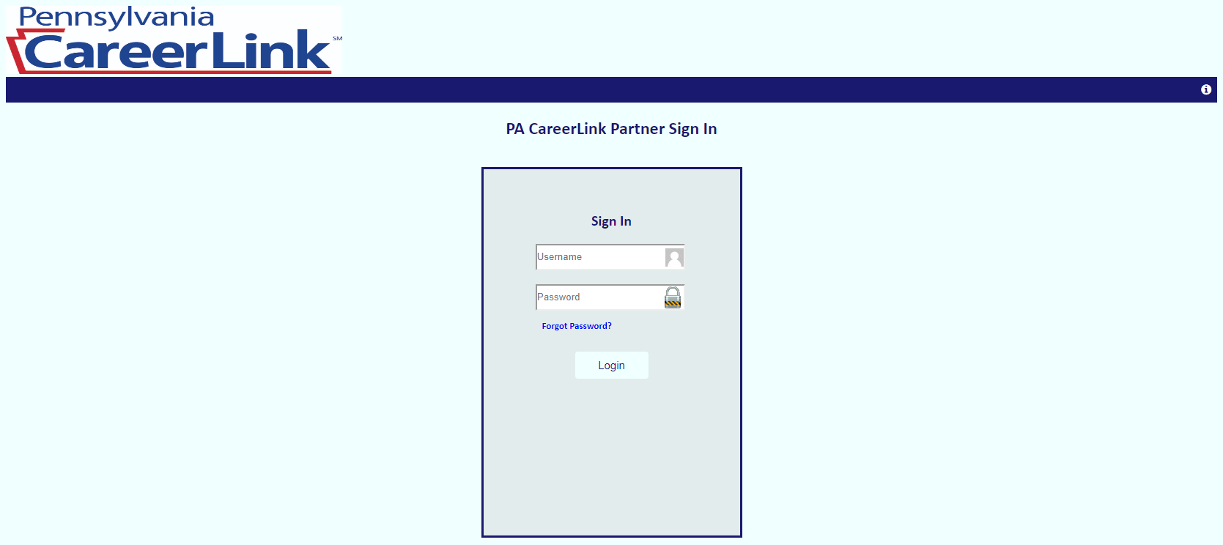

## Partner Homepage

Once the partner gains access to the Partner Homepage, they can select what kind of reporting they would like to do. A partner can do the following reporting:

* Transactions – Data pertaining to CareerLink visitor’s sign-in information (Visitor Code, Reason for visit, Office location & date/time).
* Visitors – Data pertaining to a visitor’s personal information (Visitor code, Name, Phone, Email, SSN, Education etc.)

The figure below shows the Partner Homepage.

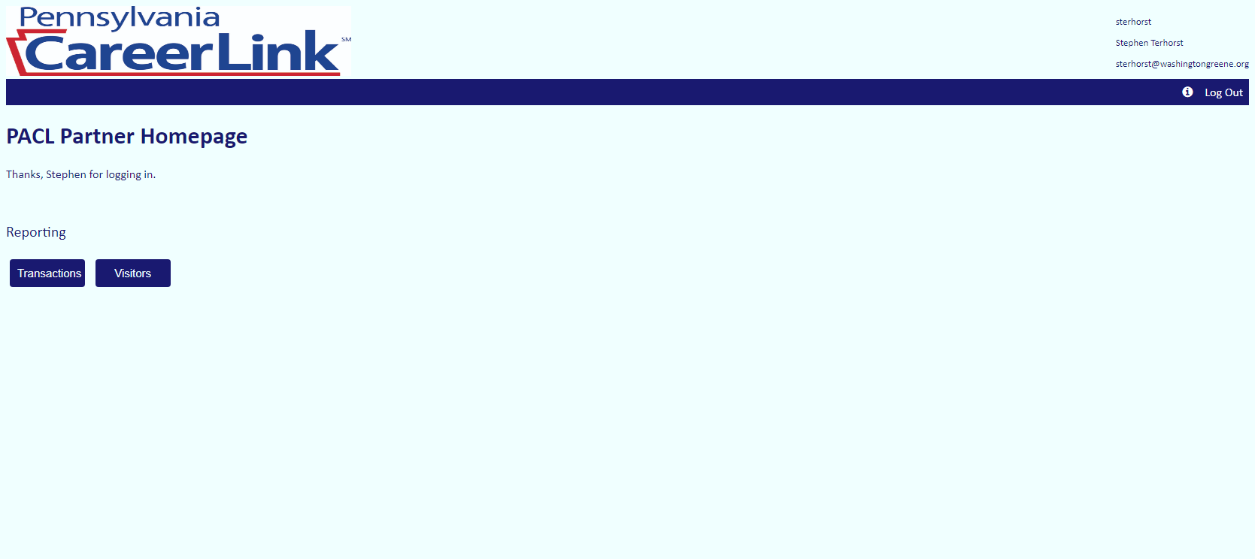

## Transaction Reporting

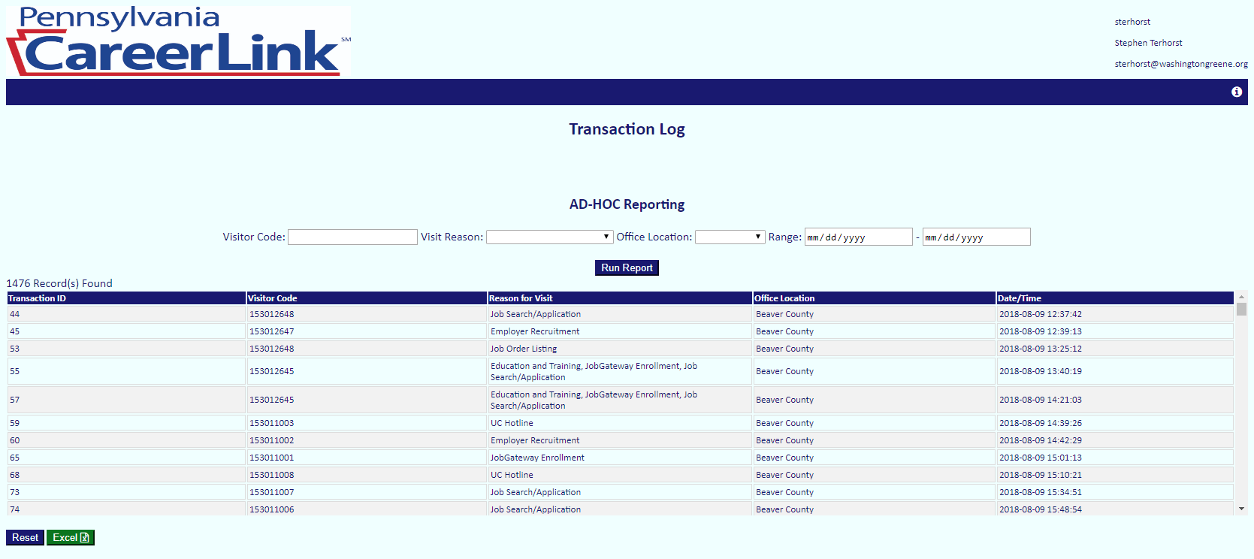On the transaction reporting page, a partner will see a table of all transactions in the centers they are subscribed to including transaction ID, visit reason, site location, and date/time. A partner can run reports on this data by entering the data they desire into any of the input boxes shown above the table. They can enter data into as many input boxes as they wish. To run the report, they will click Run Report. If a partner wants to export the AD-HOC report to excel, they can simply click the Excel button located below the table. If a partner wants to reset the table to view all transaction data, they will click Reset, also located under the table. The figure below shows the Transaction Reporting page.

## Visitor Reporting

On the Visitor Reporting page, the partner will see a table of all visitors that have registered into the system at the location they are subscribed to. The data in this table includes the visitors name, email, phone, last 4 of SSN, residing county, employment status, education, veteran status, aging status, youth status, disability status, food stamps status, and cash assistance status. A partner can run reports on this data by entering the data they desire into any of the input boxes shown above the table. They can enter data into as many input boxes as they wish. To run the report, the partner will click Run Report. If a partner wants to export the AD-HOC report to excel, they can simply click the Excel button located below the table. If a partner wants to reset the table to view all visitor data, they will click Reset, also located under the table. The figure below shows the Visitor Reporting page.

